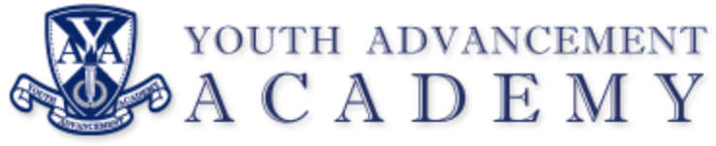

REGULAR BOARD MEETING
Chime School
6750 Chime St.
Kalamazoo, MI 49009
Tuesday, April 9, 2024
5:30 PM

AGENDA

- Call to Order Regular Meeting
  - Meeting called to order at 5:30 p.m.

II. Pledge of Allegiance

- Roll Call
  - Members present: Brown, Fielder, Saunders, Brennan, Raines, Mora

- Approval of Agenda
  - Motion to approve the agenda made by Brown, seconded by Saunders. Motion carried by unanimous voice vote.

- Public Comment – (five minute maximum)
  - No public comment

- Approval of Minutes
  - March 12, 2024, Regular Meeting
    - Motion to approve the March meeting minutes made by Fielder, seconded by Brown. Motion carried by unanimous voice vote.

- Communications
  - Director’s Report
    - No student of the month due to Spring Break
    - Staff member of the month: Ms. Carroll
    - Current enrollment at 55 students. Total students served this year is 71.
    - Graduation is set to occur May 31st at YAA
    - March monthly attendance was 85%

- Regular Agenda
  - Financial Report: Dr. Magnuson
    - Finances are on track and no unexpected issues
    - Continuing to resolve bank account access issue
  - School Facilities Update: Todd Mora
    - No new update
    - Progressing on track with scheduled move.
      - Need to contract with moving company to facility move of YAA property to new location
  - Spring Policy Updates
    - Spring policy update provided by NCSI
      - Motion to waive first read made by Raines, seconded by Saunders. Roll Call Vote
        - Brennan – Yea
        - Brown – Yea
        - Fielder – Yea
        - Raines – Yea
        - Saunders – Yea
        - Mora – Yea
          - Motion carried 6-0
      - Motion to approve the spring policies updates made by Brown, seconded by Brennan. Roll Call Vote
        - Brennan – Yea
        - Brown – Yea
        - Fielder – Yea
        - Raines – Yea
        - Saunders – Yea
        - Mora – Yea
          - Motion carried 6-0
- Public Comment (non-agenda items)
  - No public comment

- Board Comments
  - No board comments

- Adjournment
  - Meeting adjourned at 5:51 p.m.

Next Meeting: May 14, 2024 (Chime School)

